
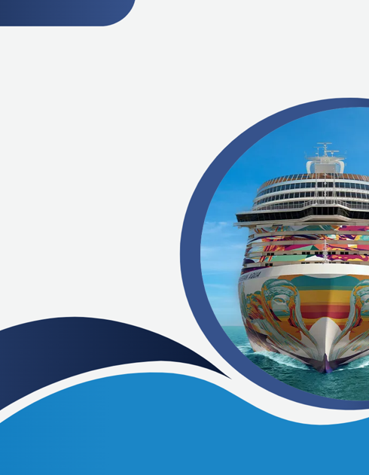
Information Technology Architecture (ITA)
Solution Design Document (SDD)
SDD Template Form Version 4.0

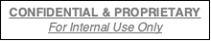
FSSO Redesign
Vendor: Fortinet

CONFIDENTIAL & PROPRIETARY
Property of Norwegian Cruise Line Holdings (NCLH)
Table of Contents
1.0 Overview 6
1.1 Executive Summary 6
1.2 Application 6
1.3 Application ID (Proposal) 6
1.4 Application Description 6
1.5 Application Owner 6
1.6 Business Owner 6
1.7 Vendor 7
1.8 Vendor Support (BeyondTrust to Jumpbox?) 7
1.9 Application Aliases 7
1.10 Number of Users for the System 7
1.11 Recovery Time Objective (RTO) / Point Objective (RPO) 8
1.12 SDD Revision History 8
2.1 New Technology Project 8
2.2 Project 8
2.3 Project Contacts – Internal 8
2.4 Stakeholders 8
2.5 Business 8
2.6 IT 8
2.7 Project Description 9
2.8 What Is New 9
2.9 Business Requirements 9
2.10 Scope 9
2.10.1 In-Scope Changes 9
2.10.2 Out of Scope 9
2.11 Project Risks & Assumptions or Risk Assessment / Exception / Mitigation 9
2.12 Clarity Project Resources Assigned 10
2.13 New Vendor 10
2.14 Plan for Pre-Prod Testing 10
2.15 Project Phase at Review 10
2.16 Environment for this Implementation 10
2.17 Data Classification / Regulation Impact 11
2.18 Approval Process 11
2.19 Legal Approval Required 11
2.20 Supporting Artifacts 12
3.0 Solution Details 13
3.1 Modules 13
3.2 Active Locations 13
3.3 Integrations Needed (i.e. Otalio / Fidelio) 13
3.4 Other Applications, File Servers, Cloud, External 13
3.5 Reporting Technologies Required 13
3.6 ITA – System Diagram 13
4.0 Networking 14
4.1 Actors 14
4.2 Firewall Rules 14
4.3 Illumio (Actual Flow Not Traversing the Firewall) 18
5.0 Server Infrastructure / Hardware – Ship (move 9.0) 21
5.1 Server Infrastructure / Technology Requirements – Hardware 21
5.2 OS Managed By 21
5.3 Licensed By 21
5.4 CPU/MEM Requirements 22
5.5 Certificate 22
5.6 DNS 22
5.7 Server Build / OVA / Physical Hardware 22
5.7.1 SNOW | Server Build/Appliance Import Tickets 23
5.8 DHCP Reservation 23
5.8.1 Title 23
5.9 MDM 23
5.9.1 TCO 23
5.10 Service Accounts and Groups 23
5.10.1 IAM Requirements 23
5.10.2 Beyond Trust VPN Access 23
5.10.2.1 AD Account 23
5.10.2.2 AD Account IDP Group 23
5.10.3 Service Accounts 23
5.10.4 Wi-Fi Accounts 24
5.10.5 Okta Request 24
6.0 Infrastructure Cloud 24
6.1 Kafka 24
6.2 AWS 24
6.3 Certificate 25
6.4 DNS 25
6.5 Service Accounts and Groups 25
6.5.1 IAM Requirements 25
6.5.2 Okta/Beyond Trust 25
6.5.3 Service Accounts 25
6.5.4 Wi-Fi Accounts 25
9.0 Vendor Information 25
9.1 Vendor Supporting Documentation 25
9.2 Vendor – Future Proposed Architecture – High-Level Diagram 28
9.3 Vendor – Future Proposed Architecture – Low-Level Diagram 28
9.4 Vendor – Future Proposed Architecture – Data Flow 29
10.0 Appendix 29

1.0 Overview

1.1 Executive Summary
Currently NCL deployment has both the FSSO Collector Agent (CA) and the Domain Controller Agents on the ship’s Domain Controllers. Since the Network Team does not have direct management access to these Domain Controllers, this setup has presented several challenges such as dependency on Server team, limited access hindering troubleshooting/upgrades, miscommunications, and complexities with backup/recovery.
To address these issues, the recommended architecture involves deploying the FSSO Collector Agent on a dedicated VM. This solution also provides the Network Team with greater control, faster troubleshooting, and enhanced redundancy for the FSSO service.

1.2 Application
Fortinet FSSO

1.3 Application ID (Proposal)
This will be available after SDD approval and submission to SNOW mapped application service

1.4 Application Description
The Fortinet FSSO (Fortinet Single Sign-On) Collector is a robust tool designed to enhance network security by integrating Fortinet devices with various authentication systems. It centralizes user authentication data from sources like Active Directory and LDAP, providing real-time user identification and seamless integration with Fortinet security products.
Key Features:
Centralized Authentication: Consolidates user data from multiple sources for simplified management.
Real-Time Identification: Monitors user login events for immediate policy application.
Seamless Integration: Works with FortiGate, FortiAuthenticator, and FortiAnalyzer.
Enhanced Security Policies: Allows granular control based on user identity.
Scalability: Supports large networks with high authentication capacity.
Comprehensive Reporting: Provides detailed logs and reports for auditing.
Benefits:
Improved Security: Consistent application of security policies.
Simplified Management: Reduces complexity in user access administration.
Enhanced User Experience: Streamlined and secure authentication process.
The Fortinet FSSO Collector is essential for organizations seeking efficient and centralized user authentication management to bolster network security.

1.5 Application Owner
Role | Name | Email
Dir Network Svcs Shipboard | Jamlet Tapanes | jtapanes@nclcorp.com
Choose an item. | Click or tap here to enter text. | Click or tap here to enter text.

1.6 Business Owner
Role | Name | Email
Dir Network Svcs Shipboard | Jamlet Tapanes | jtapanes@nclcorp.com
Choose an item. | Click or tap here to enter text. | Click or tap here to enter text.

1.7 Vendor
Name | Contact Number | Email
Click or tap here to enter text. | Click or tap here to enter text. | Click or tap here to enter text.

1.8 Vendor Support (BeyondTrust to Jumpbox?)
N/A

1.9 Application Aliases
N/A

1.10 Number of Users for the System
N/A

1.11 Recovery Time Objective (RTO) / Point Objective (RPO)
Each ship will have two Server for High availability.

1.12 SDD Revision History
Version | Name / Role | Changes Made | Date
1.0 | Osvaldo Quinones, Sr Technical Manager | Document Creation | 6/6/2025

2.1 New Technology Project
SNOW (REQ#) | Author | Description
Pending | Click or tap here to enter text. | Click or tap here to enter text.
2.2 Project
NCLH is partnering with Fortinet to review current solutions and to optimize according to Fortinet best practices. Currently NCL deployment has both the FSSO Collector Agent (CA) and the Domain Controller Agents on the ship’s Domain Controllers. Since the Network Team does not have direct management access to these Domain Controllers, this setup has presented several challenges such as dependency on Server team, limited access hindering troubleshooting/upgrades, miscommunications, and complexities with backup/recovery. To address these issues, the recommended architecture involves deploying the FSSO Collector Agent on a dedicated VM. This solution also provides the Network Team with greater control, faster troubleshooting, and enhanced redundancy for the FSSO service.

2.3 Project Contacts – Internal
Role | Title | Email
Project Manager | Eduardo Cendan | ecendan@ncl.com
Business Analyst | Dina Leznova | dleznova@ncl.com
Portfolio Director | Simon Falcon | dleznova@ncl.com
Lead Shipboard Network Ops | Manuel Sosa | msosa@nclcorp.com
Network Engineer II | Alejandro Power | Apower@nclcorp.com

2.4 Stakeholders
Role | Title | Email
Executive Sponsor | Georgios Mortakis | gmortakis@nclcorp.com
Initiative Owner | Jamlet Tapanes | jtapanes@nclcorp.com

2.5 Business
Role | Title | Email
Executive Sponsor | Georgios Mortakis | gmortakis@nclcorp.com
Initiative Owner | Jamlet Tapanes | jtapanes@nclcorp.com

2.6 IT
Role | Title | Email
IT Architect | Osvaldo Quinones | oquinones@ncl.com
IT Architect | Cindy More | cmore@ncl.com

2.7 Project Description
Currently NCL deployment has both the FSSO Collector Agent (CA) and the Domain Controller Agents on the ship’s Domain Controllers. Since the Network Team does not have direct management access to these Domain Controllers, this setup has presented several challenges such as dependency on Server team, limited access hindering troubleshooting/upgrades, miscommunications, and complexities with backup/recovery for the FSSO service.

2.8 What Is New
To address these issues, Integrator partners recommend deploying the FSSO Collector Agent (CA) on a dedicated virtual machine, separate from the domain controllers. Alternatively, leveraging a FortiAuthenticator (FAC) device (either as a VM or physical appliance) to perform the CA functions offers significant benefits.

2.9 Business Requirements
ID | Business Requirements
BR-01 | Deploy the FSSO Collector Agent (CA) on a dedicated virtual machine, separate from the domain controllers
BR-02 | Deploy the server under the Network Team’s management
BR-03 | Configure multiple CAs for redundancy

2.10 Scope

2.10.1 In-Scope Changes
In-Scope: All Brands, Harvest Caye, Great Stirrup Cay
Deploying the FSSO Collector Agent on a dedicated virtual machine, separate from the domain controllers.
2 Servers per site for HA
Domain Controller Agent:
The Domain Controller (DC) Agent must be installed on each domain controller when operating in DC Agent mode. The DC Agents monitor user logon events and pass this information to the Collector Agent, which stores and forwards the data to the FortiGate unit.

2.10.2 Out of Scope
Modification of any other infrastructure component not associated to FSSO Collector Agent functions is not in the scope of this project.

2.11 Project Risks & Assumptions or Risk Assessment / Exception / Mitigation
N/A

2.12 Clarity Project Resources Assigned
Name | Role / Title | Email
Nicolas Serrundo | Windows Admin | nserrudo@nclcorp.com
Alejandro Power | Network Engineer II | apower@nclcorp.com
Manuel Sosa | Lead Shipboard Network Ops | msosa@nclcorp.com
Osvaldo Quinones | Sr Technical Manager | oquinones@ncl.com

2.13 New Vendor
content

2.14 Plan for Pre-Prod Testing
The solution will be tested on Discovery lab before fleet deployment.

2.15 Project Phase at Review
☒ | Initialed | ☒ | Development | ☐ | Other:
☐ | Testing | ☐ | Implementation | ☐ | Other:

2.16 Environment for this Implementation
☒ | Shipboard (On-Premises) | ☐ | Private Enterprise Cloud | ☒ | NCLH AWS Cloud
☐ | Shoreside (On-Premises) | ☐ | Vendor Cloud | ☐ | Other:

2.17 Data Classification / Regulation Impact
PII | Select | ☐ | Attestation Included
SOX | Select | ☐ | Attestation Included
PCI | Select | ☐ | Attestation Included
PHI | Select | ☐ | Attestation Included
Encryption Required | Select | ☐ | Encryption methodology Included
Other | Select | ☐

2.18 Approval Process
Approval Status |  | Approval Notes |  |  |  | Approval Date
☐ | Final | Choose an item. |  |  |  | Click or tap to enter a date.
☐ | Conditional
Reviewer / Approval Name(s) |  |  |  |  | Review Date
Osvaldo Quinones, Sr Technical Manager |  |  |  |  | 6/6/2025
Cindy More, Sr Solution Architect |  |  |  |  | 6/9/2025
Click or tap here to enter text. |  |  |  |  | Click or tap to enter a date.
Click or tap here to enter text. |  |  |  |  | Click or tap to enter a date.
Requires ARB Waiver / Exceptions |  |  | ARB Outcome
Choose an item. |  |  | Click or tap here to enter text.
Standards |  |  |  | Standard Reference Number
☒ | Requires a new standard |  |  | Click or tap here to enter text.
☐ | Requires an update to existing standards |  |  | Click or tap here to enter text.
☐ | No standard change is required. |  |  | Click or tap here to enter text.

2.19 Legal Approval Required
Not Required | Click or tap to enter a date. | Click or tap here to enter text.

2.20 Supporting Artifacts
Attestation Links and Commentary
Security
Attestation Links and Commentary
☐ | PII Attestation | <<Attestation Document Title and Hyperlink>>
☐ | SOX Attestation | <<Attestation Document Title and Hyperlink>>
☐ | PCI Attestation | <<Attestation Document Title and Hyperlink>>
☐ | PHI Attestation | <<Attestation Document Title and Hyperlink>>
☐ | Encryption Methodology | <<Attestation Document Title and Hyperlink>>
☐ | Click or tap here to enter text.
Vendor
Vendor Supporting Documentation
☐ | Vendor Questionnaire | <<Attestation Document Title and Hyperlink>>
☐ | Vendor NDA (Non-Disclosure Agreement) | <<Attestation Document Title and Hyperlink>>
☐ | Vendor MSA (Master Service Agreement) | <<Attestation Document Title and Hyperlink>>
☐ | Vendor SOW (Statement of Work) | <<Attestation Document Title and Hyperlink>>
☒ | BRD (Business Requirements Document) | <<Attestation Document Title and Hyperlink>>

3.0 Solution Details

3.1 Modules
N/A

3.2 Active Locations
All Brands, Harvest Caye, Great Stirrup Cay

3.3 Integrations Needed (i.e. Otalio / Fidelio)
N/A

3.4 Other Applications, File Servers, Cloud, External
Integration with Domain Controller on site and cloud

3.5 Reporting Technologies Required
N/A

3.6 ITA – System Diagram
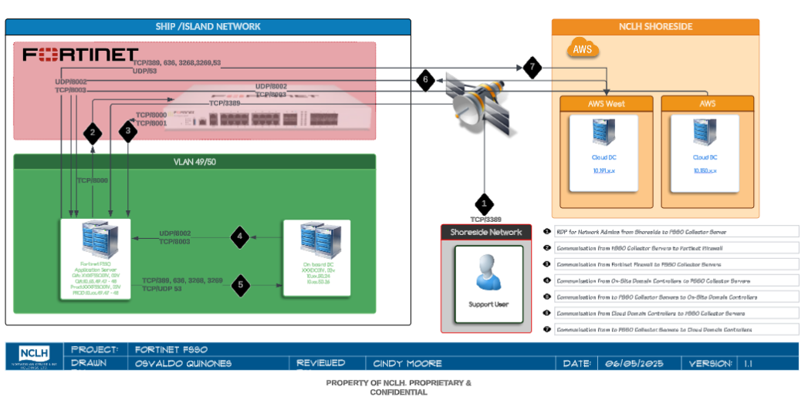
Figure 1 - ITA Architecture
(PDF attached for better reading)
Attach PDF Object

4.0 Networking

4.1 Actors

4.2 Firewall Rules

4.2 Firewall Rules (continue)

4.2 Firewall Rules (continue)

4.2 Firewall Rules (continue)

4.3 Illumio (Actual Flow Not Traversing the Firewall)
(PDF attached for better reading)

5.0 Server Infrastructure / Hardware – Ship (move 9.0)

5.1 Server Infrastructure / Technology Requirements – Hardware
Project | Fortinet FSSO
Server Description | Fortinet FSSO Collector Server
Note
Server Purpose |  | Data Center | Operation System | Server Type | VLAN
Fortinet FSSO Collector Server |  | Shipboard | Windows Server 2019 | Virtual | 49

5.2 OS Managed By
NCLH

5.3 Licensed By
NCLH

5.4 CPU/MEM Requirements
2 CPU/8GB RAM

5.5 Certificate
N\A

5.6 DNS
FSSO Server will use as DNS on premises (Shipboard/Island) and AWS Domain controllers

5.7 Server Build / OVA / Physical Hardware
Server Build Request Required
Yes

5.7.1 SNOW | Server Build/Appliance Import Tickets
SNOW Request Type | Request Number | Description
Request Type | REQ Number | Click or tap here to enter text.
Request Type | REQ Number | Click or tap here to enter text.
Click or tap here to enter text.

5.8 DHCP Reservation

5.8.1 Title
N/A

5.9 MDM
N/A

5.9.1 TCO

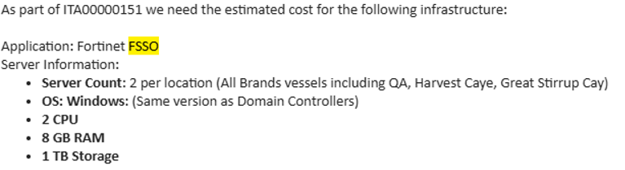
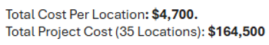

5.10 Service Accounts and Groups

5.10.1 IAM Requirements
N/A

5.10.2 Beyond Trust VPN Access
N/A
5.10.2.1 AD Account
N/A

5.10.2.2 AD Account IDP Group
Click or tap here to enter text.

5.10.3 Service Accounts
Existent: fgad@xxx.ncl.com

5.10.4 Wi-Fi Accounts
N/A

5.10.5 Okta Request
N/A

6.0 Infrastructure Cloud

6.1 Kafka
N/A

6.2 AWS

6.3 Certificate
N/A

6.4 DNS
In addition to onsite (Shipboard, Islands) AWS domain controllers will provide DNS functionality to the FSSO Servers

6.5 Service Accounts and Groups

6.5.1 IAM Requirements
N/A

6.5.2 Okta/Beyond Trust
N/A

6.5.3 Service Accounts
N/A

6.5.4 Wi-Fi Accounts
N/A

9.0 Vendor Information

9.1 Vendor Supporting Documentation
Based on NCLH’s requirements and the existing architecture deployed across the shipboard environment and its domain, please find below the recommended architecture for Fortinet Single Sign-On (FSSO).
Current Setup and Challenges
Currently NCL deployment has both the FSSO Collector Agent (CA) and the Domain Controller (DC) Agents on the ship’s Domain Controllers. Since the Network Team does not have direct management access to these Domain Controllers, this setup has presented several challenges:
- Dependency on Other Teams: Troubleshooting issues often requires coordination with the Server Team, creating delays and complexities.
- Increased Potential for Misconfiguration: Limited access to the Domain Controllers increases the risk of misconfigurations, such as FortiGate to CA password mismatches, incorrect filters, and issues arising during upgrades or reinstallations.
- Complexities in Backup and Recovery: In the event of a failure or maintenance on the Domain Controller, having the CA on the same VM increases the recovery time and may complicate backup processes. A dedicated CA or FortiAuthenticator device can be restored independently, ensuring smoother recovery and continuity of the FSSO service.

Proposed Architecture
To address these issues, we recommend deploying the FSSO Collector Agent (CA) on a dedicated virtual machine, separate from the domain controllers. Alternatively, leveraging a FortiAuthenticator (FAC) device (either as a VM or physical appliance) to perform the CA functions offers significant benefits.
This architecture provides the following advantages:
- Enhanced Troubleshooting and Management: By placing the CA functions on FortiAuthenticator or a dedicated server under the Network Team’s management, troubleshooting is simplified, minimizing dependencies on the Server Team, and enabling quicker issue resolution.
- Reduced Risk of Misconfigurations: Managing the FSSO configuration independently allows for better control over settings, reducing the chances of misconfigurations (e.g., FortiGate CA password mismatches and incorrect filter settings). FortiAuthenticator provides a stable and consistent platform that minimizes configuration drift.
- Improved Resilience and Redundancy: FortiGate devices support up to five CAs for redundancy. By configuring multiple CAs, including FortiAuthenticator, we can enhance the resilience of the FSSO deployment. If the primary CA is unreachable, FortiGate can automatically switch to the next available CA, ensuring continuous operation.
- Streamlined Maintenance and Reduced Server Dependency: FortiAuthenticator acts as a standalone solution for FSSO, eliminating the need for a Windows server for CA functions. This approach reduces the need for OS patching, maintenance, and frequent updates, greatly simplifying management.
Collector Agent and FortiAuthenticator Details
The Collector Agent (CA) or FortiAuthenticator (FAC) monitors user logons within the Windows AD network and sends necessary authentication information to the FortiGate. Key functionalities include:
- DNS Lookups, Group Verification, and Workstation Checks: The CA or FAC verifies user credentials, group memberships, and workstation status before relaying logon records to FortiGate.
- Communication with FortiGate Devices: Both the CA and FAC communicate with FortiGate over TCP port 8000 for logon information updates and listen on UDP port 8002 to receive updates from the DC Agents.
- Redundant CA/FAC Configuration: Multiple CA or FAC instances can be configured on FortiGate for high availability. If one becomes unreachable, FortiGate will attempt connection to the next configured CA or FAC in sequence.

Domain Controller Agent
The Domain Controller (DC) Agent must be installed on each domain controller when operating in DC Agent mode. The DC Agents monitor user logon events and pass this information to the Collector Agent or FortiAuthenticator, which stores and forwards the data to the FortiGate unit.

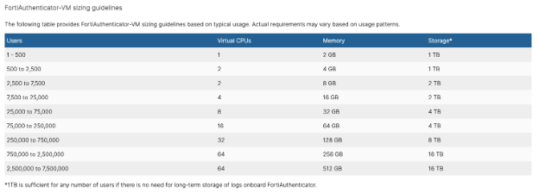

Collector Agent (CA) VM Requirements
For environments opting for a dedicated CA VM, the following specifications are recommended based on deployment size:
- Light Load: 2 vCPUs, 8 GB RAM
- Medium Load: 4 vCPUs, 16 GB RAM
- Heavy Load: 8 vCPUs, 32 GB RAM
Any server capable of running Windows Server OS should be sufficient for the FSSO Collector Agent, but the above guidelines ensure optimal performance.

Summary
This recommended architecture involves deploying the FSSO Collector Agent on a dedicated VM or utilizing FortiAuthenticator as a robust alternative. FortiAuthenticator’s value lies in its ability to perform CA functions independently of a Windows server, reducing maintenance requirements and simplifying management. This solution also provides the Network Team with greater control, faster troubleshooting, and enhanced redundancy for the FSSO service.

9.2 Vendor – Future Proposed Architecture – High-Level Diagram
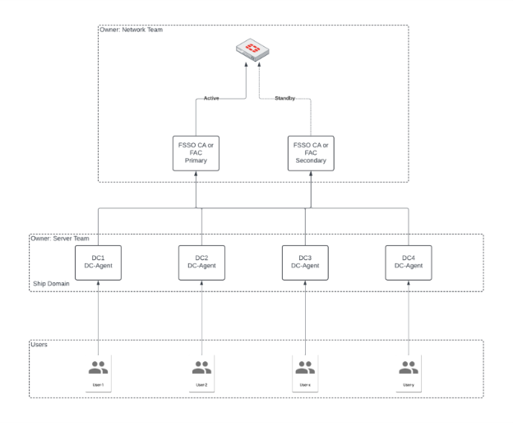
Figure 2 - Vendor – Future Proposed Architecture – High-Level Diagram

9.3 Vendor – Future Proposed Architecture – Low-Level Diagram
N/A

9.4 Vendor – Future Proposed Architecture – Data Flow
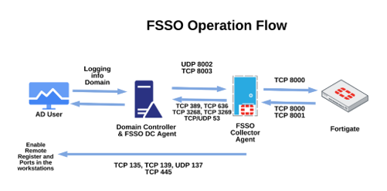
Figure 3 - Vendor – Future Proposed Architecture – Data Flow

10.0 Appendix

